**Viftech**

**Innovating the future**

**ISSUE 1:**

**Title:**

**Send Message** Issue.

**Description:**

URL: <http://viftech.linuxdemos.me/>

Resolution: **1920x1080**

**Steps to Reproduce:**

**Step1:** Click on **Send Message** button.

**Step2:** when we do not fill the field and then click on **Send Message.**

**Step3:** It should show **Error.**

**Step4:** It’s not showing Error.

**Step5:** Validation is not proper.

**Step5:** There should be a proper validation.

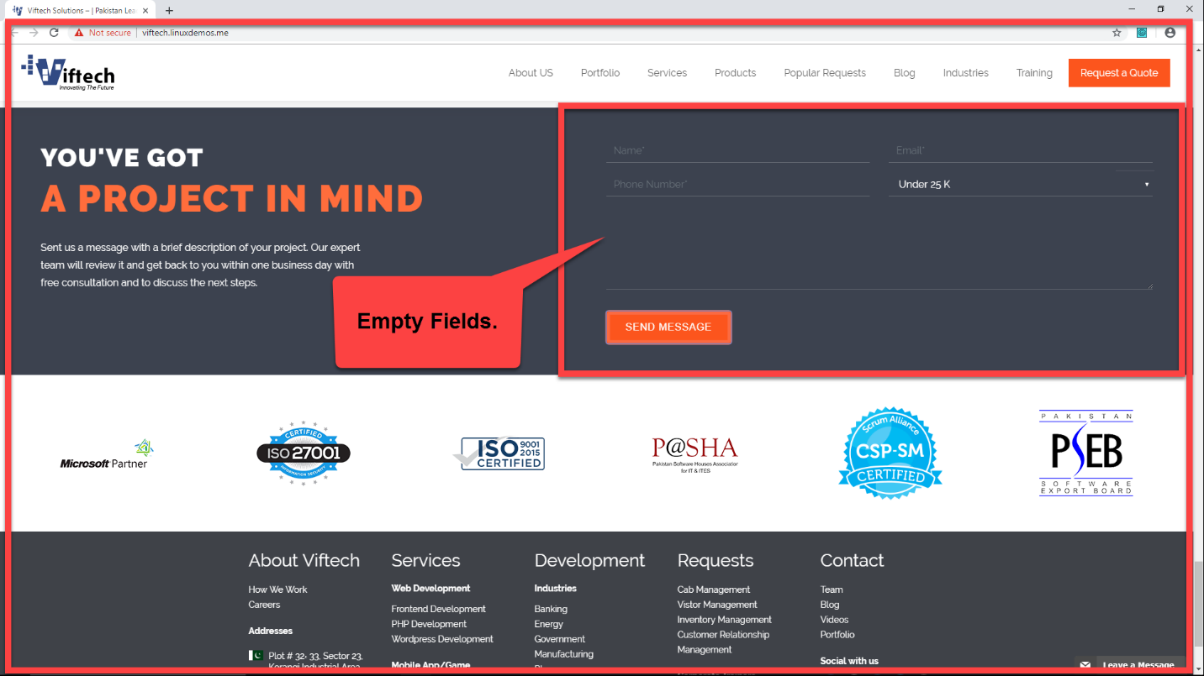

**ISSUE 2:**

**Title:**

**Send Message** Issue.

**Description:**

URL: <http://viftech.linuxdemos.me/>

Resolution: **1920x1080**

**Steps to Reproduce:**

**Step1:** Click on **Send Message** button.

**Step2:** when we fill the field and then click on **Send Message.**

**Step3:** It should show message**.**

**Step4:** It’s not showing message.

**Step5:** Validation is not proper.

**Step5:** There should be a proper validation.

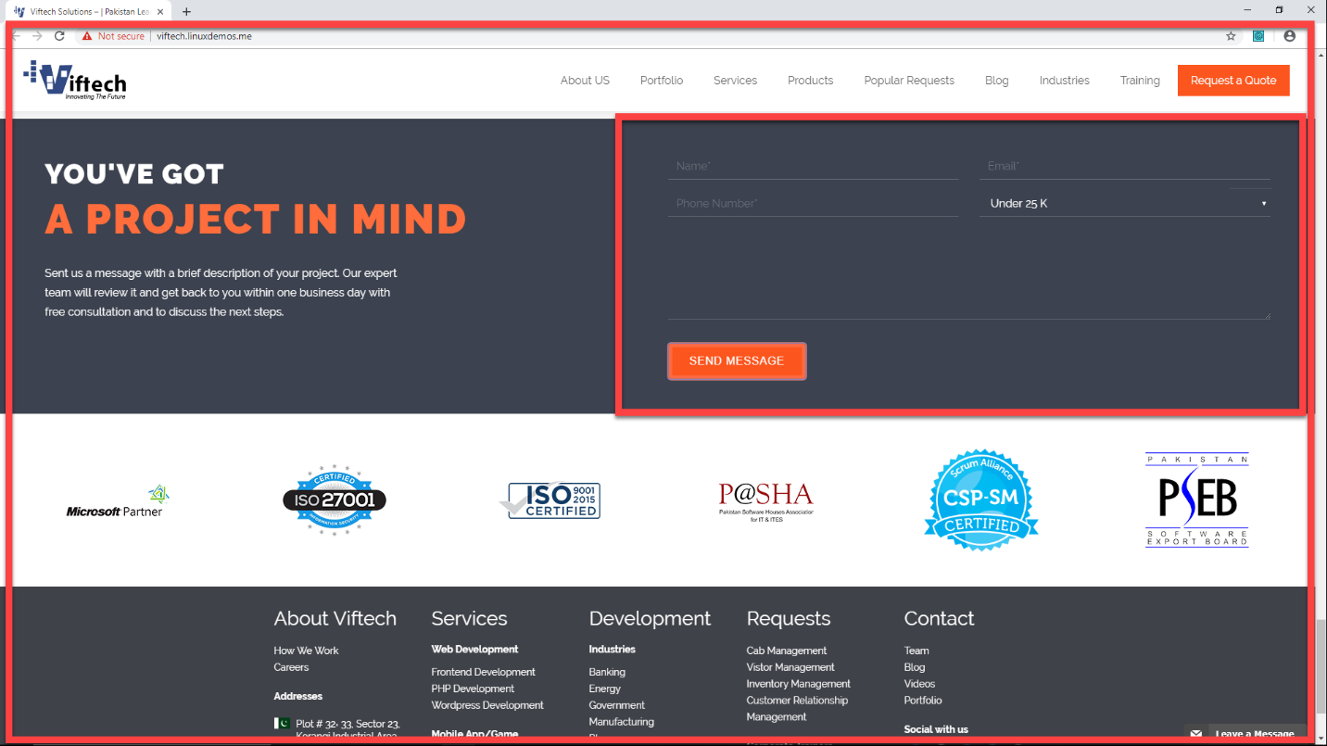

**ISSUE 3:**

**Title:**

Php web development View portfolio Button issue:

**Description:**

URL: <http://viftech.linuxdemos.me/php-web-development/>

Resolution: **1920x1080**

**Steps to Reproduce:**

**Step1:** View portfolio button is not aligned.

**Step2:** This Button should be aligned.

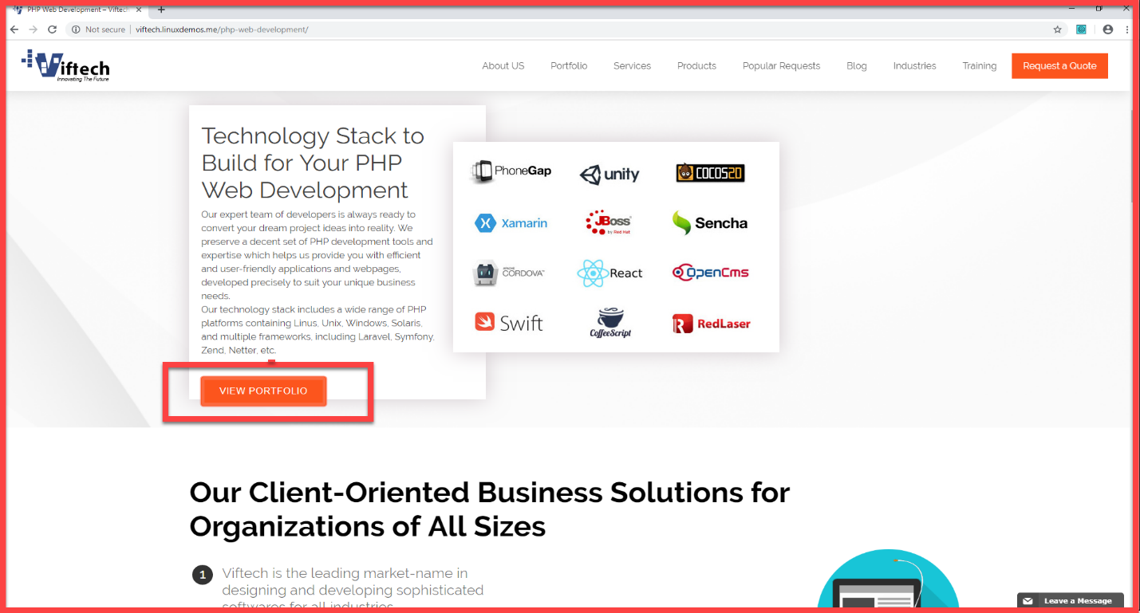

**ISSUE 3:**

**Title:**

Sap Learn more issue.

**Description:**

URL: <http://viftech.linuxdemos.me/sap/>

Resolution: **1920x1080**

**Steps to Reproduce:**

**Step1:** Go to Sap Solution Page.

**Step2:** Click on Fiori learn link.

**Step3:** When we click on Fiori learn more link it should take us on Fiori page but its take us back at sap solution page.

**Step4:** There should be a proper redirection.

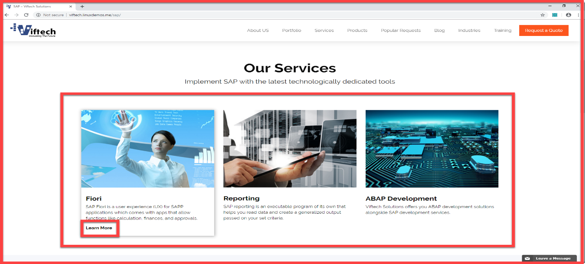

**ISSUE 4:**

**Title:**

Sap Learn more issue.

**Description:**

URL: <http://viftech.linuxdemos.me/ruby-on-rails/>

Resolution: **1920x1080**

**Steps to Reproduce:**

**Step1:** View portfolio button is not aligned

**Step2:** This Button should be aligned

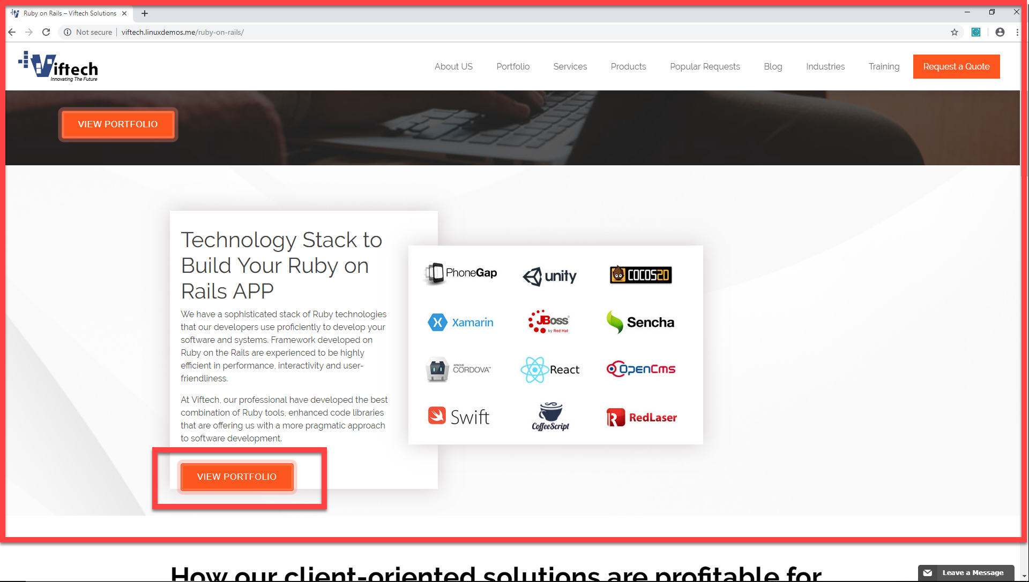

**ISSUE 5:**

**Title:**

Sap Learn more issue.

**Description:**

URL: <http://viftech.linuxdemos.me/ssis/>

Resolution: **1920x1080**

**Steps to Reproduce:**

**Step1:** View portfolio button is not aligned

**Step2:**  This Button should be aligned

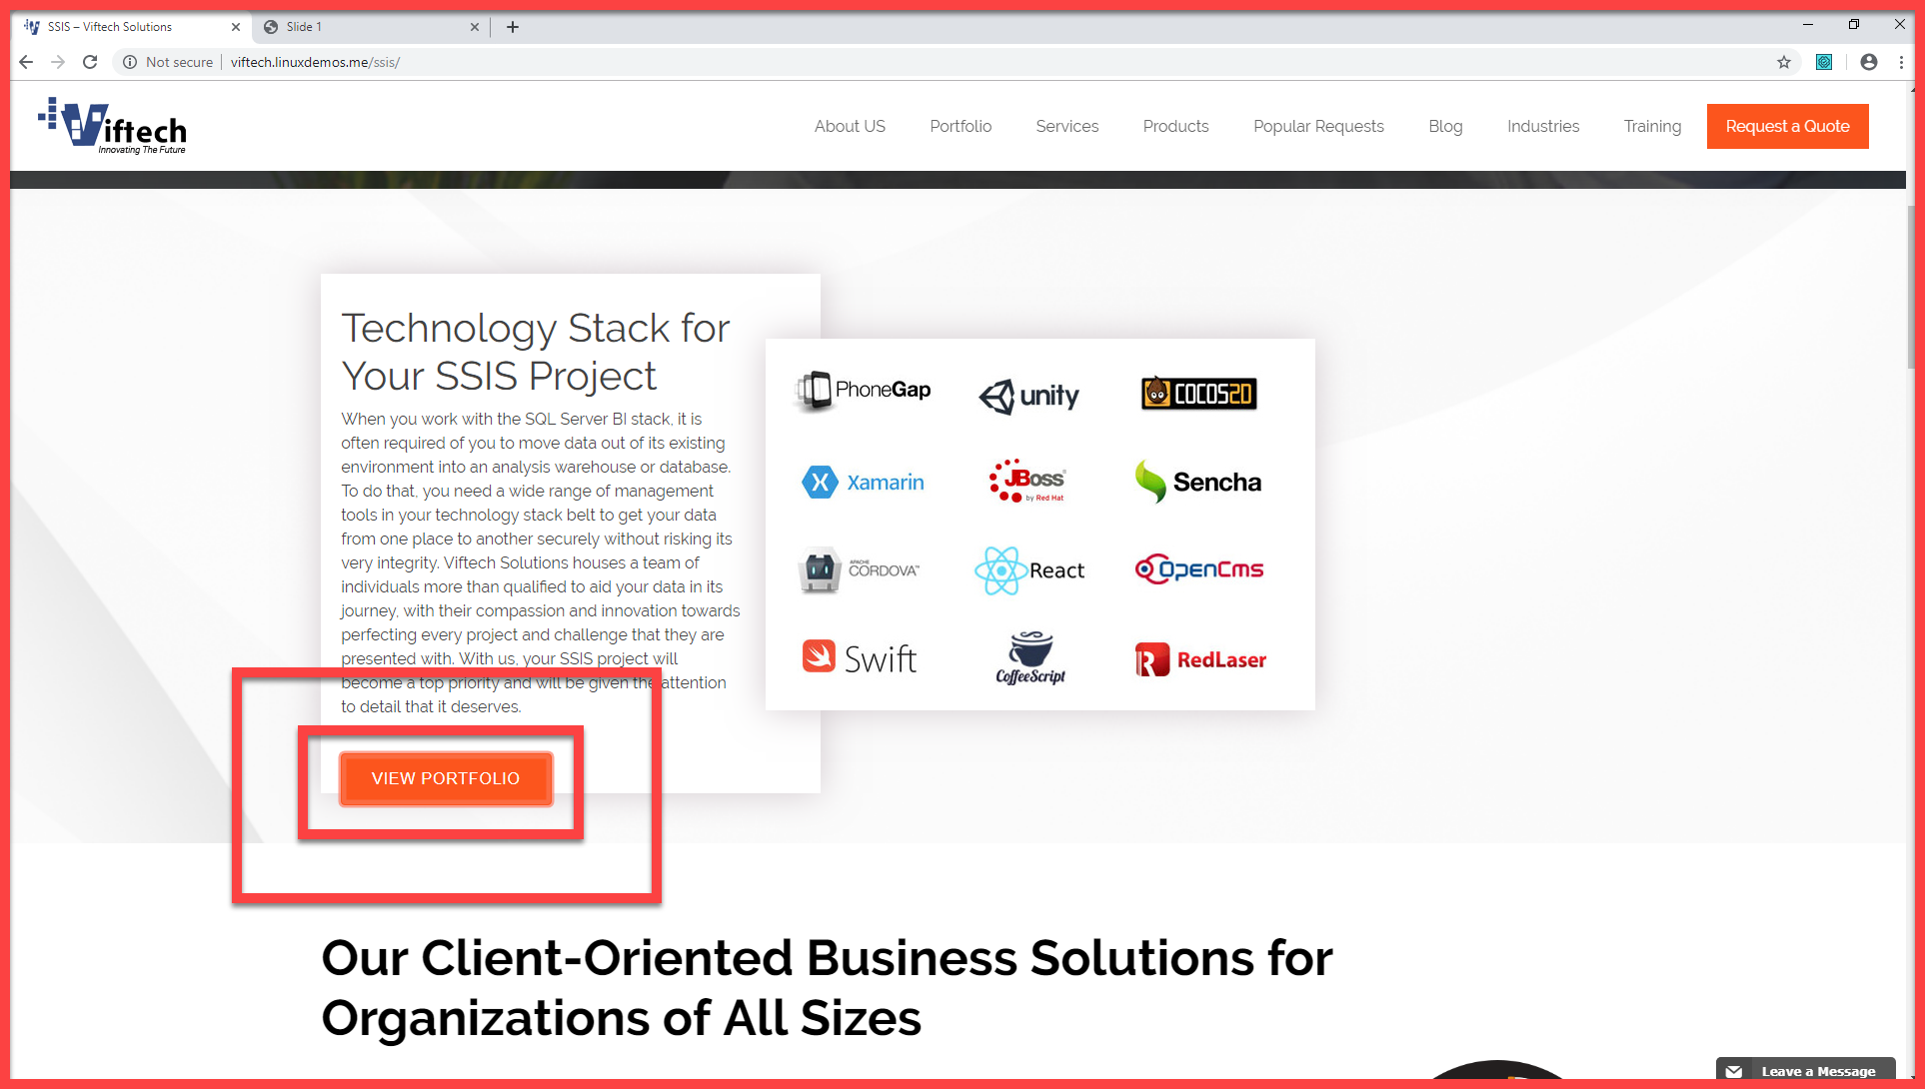

**ISSUE 6:**

**Title:**

On the Footer Issue

**Description:**

URL: <http://viftech.linuxdemos.me/>

Resolution: **1920x1080**

**Steps to Reproduce:**

**Step1:** On the footer when we click on Social with us link.

**Step2:** The links are not opening properly.

**Step3:** The links should be open properly

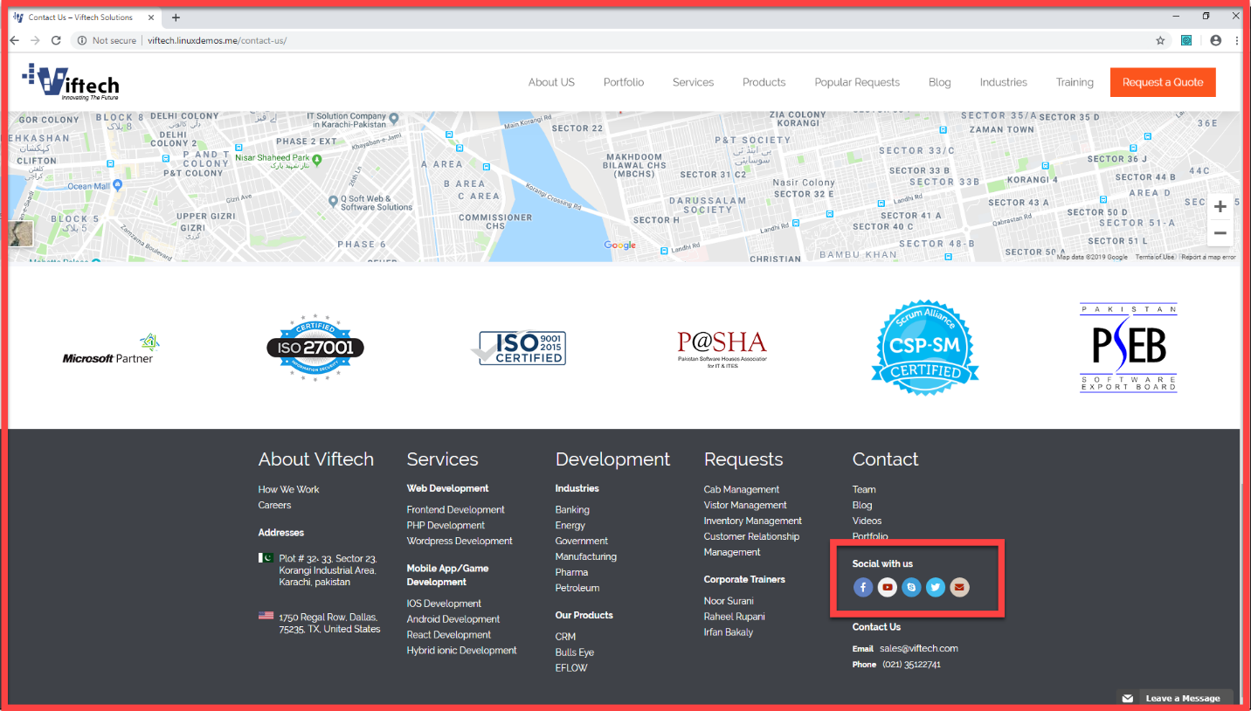

**ISSUE 7:**

**Title:**

Portfolio STC Issue.

**Description:**

URL: <http://viftech.linuxdemos.me/ssis/>

Resolution: **1920x1080**

**Steps to Reproduce:**

**Step1:** Go to portfolio and click on website.

**Step2:** When we click on STC learn more link.

**Step3:** Its should take to STC page but it take it back to portfolio our service page.

**Step4:** There should be a proper redirection.

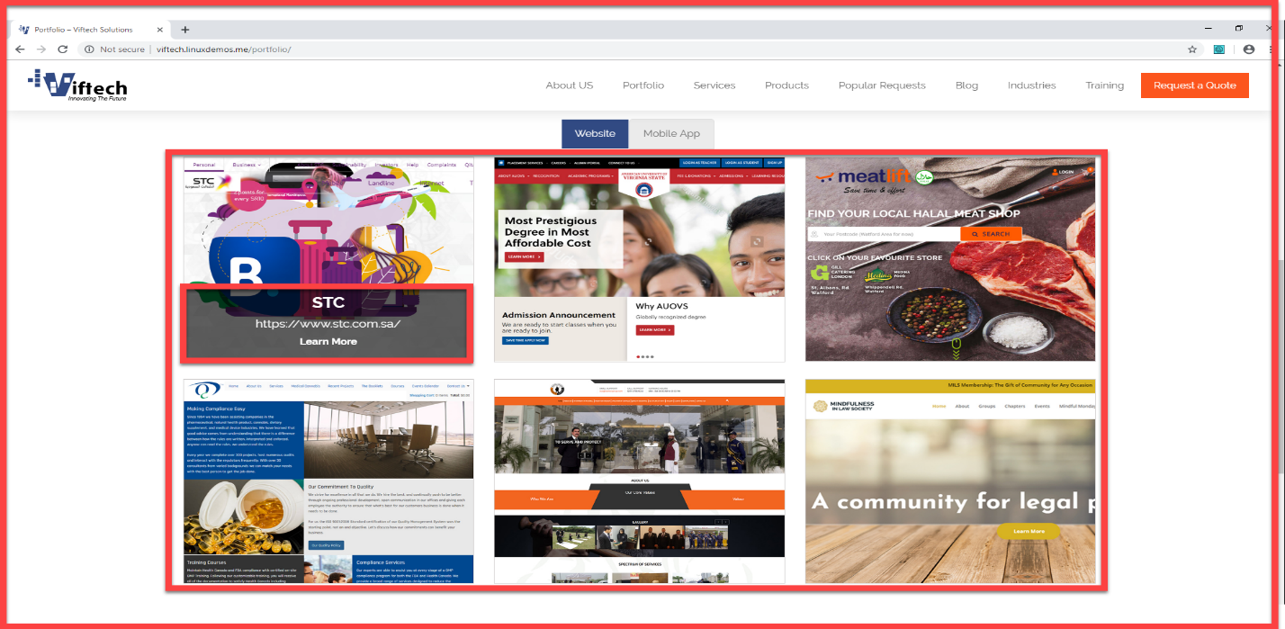

**ISSUE 8:**

**Title:**

Share point-on- premises Issue.

**Description:**

URL: <http://viftech.linuxdemos.me/sharepoint-on-premises/>

Resolution: **1920x1080**

**Steps to Reproduce:**

**Step1:** Go to SSAS page.

**Step2:** There should be space between texts.

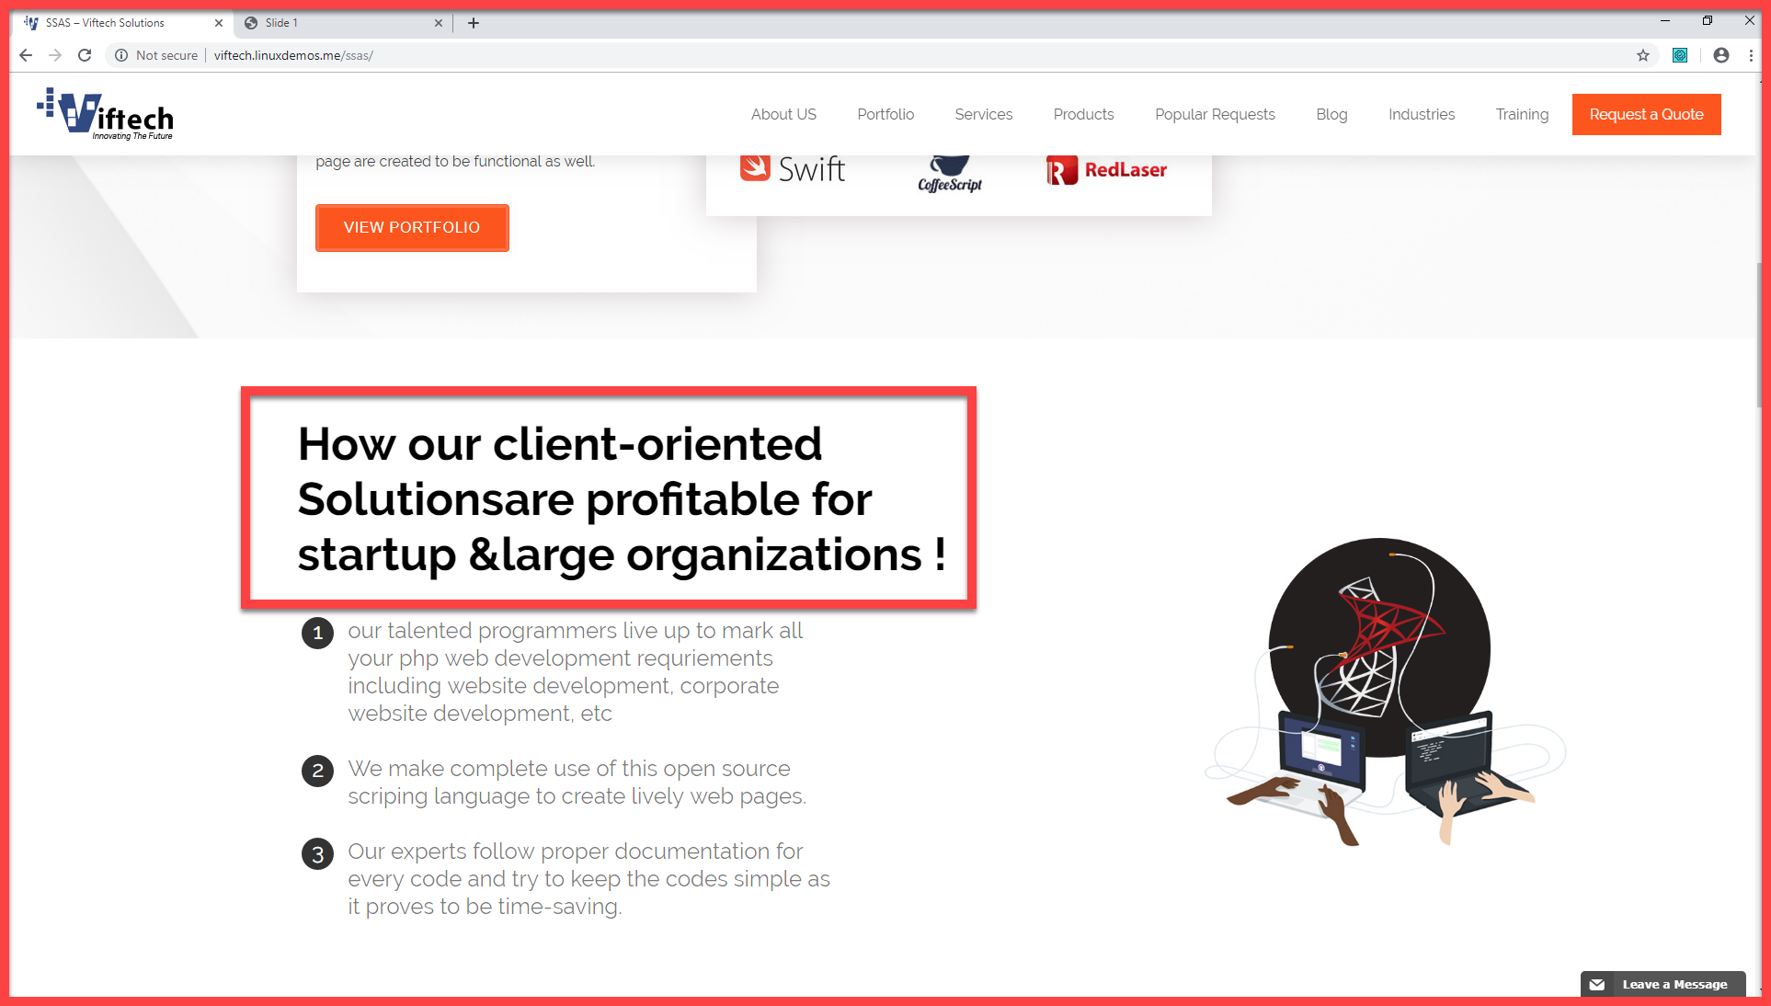

**ISSUE 9:**

**Title:**

Data-warehousing-Service Issue.

**Description:**

URL: <http://viftech.linuxdemos.me/data-warehousing-services/>

Resolution: **1920x1080**

**Steps to Reproduce:**

**Step1:** Go to Data-warehousing

**Step2:** Click on ETL Learn more link

**Step3:** Its should take to ETL page but it take it back to Data-warehousing-Service page.

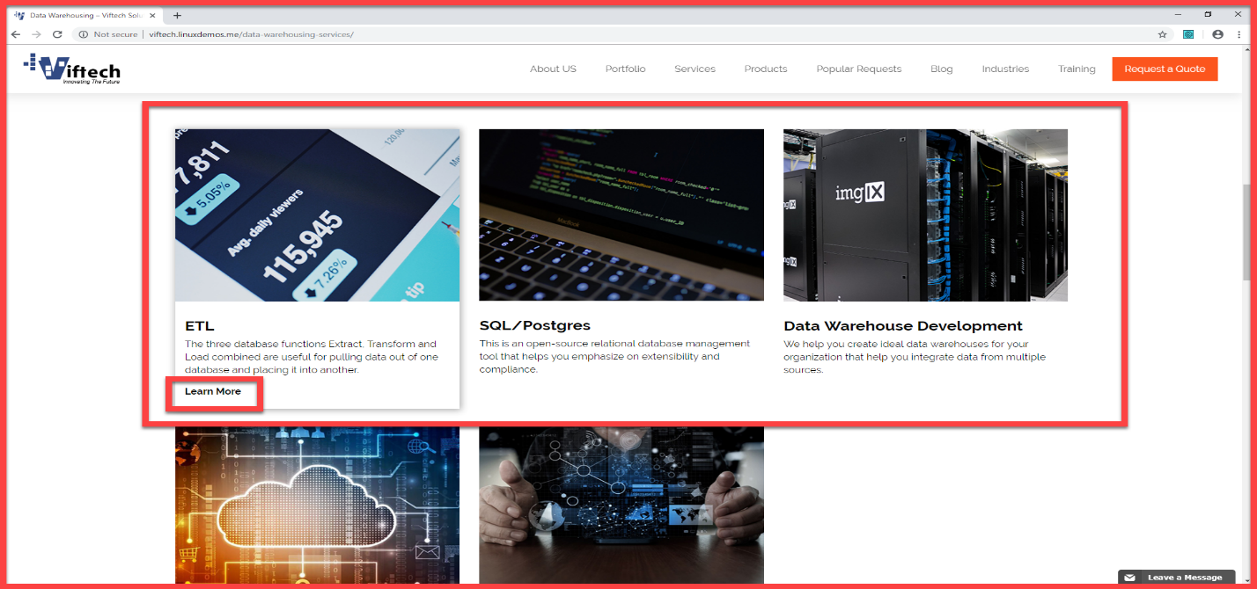**Step4:** There should be a proper redirection.

**ISSUE 10:**

**Title:**

trainer’s profile Issue.

**Description:**

URL: <http://viftech.linuxdemos.me/trainers-profile/>

Resolution: **1920x1080**

**Steps to Reproduce:**

**Step1:** Go to trainer’s profile.

**Step2:** The trainer’s profile link should be in Center.

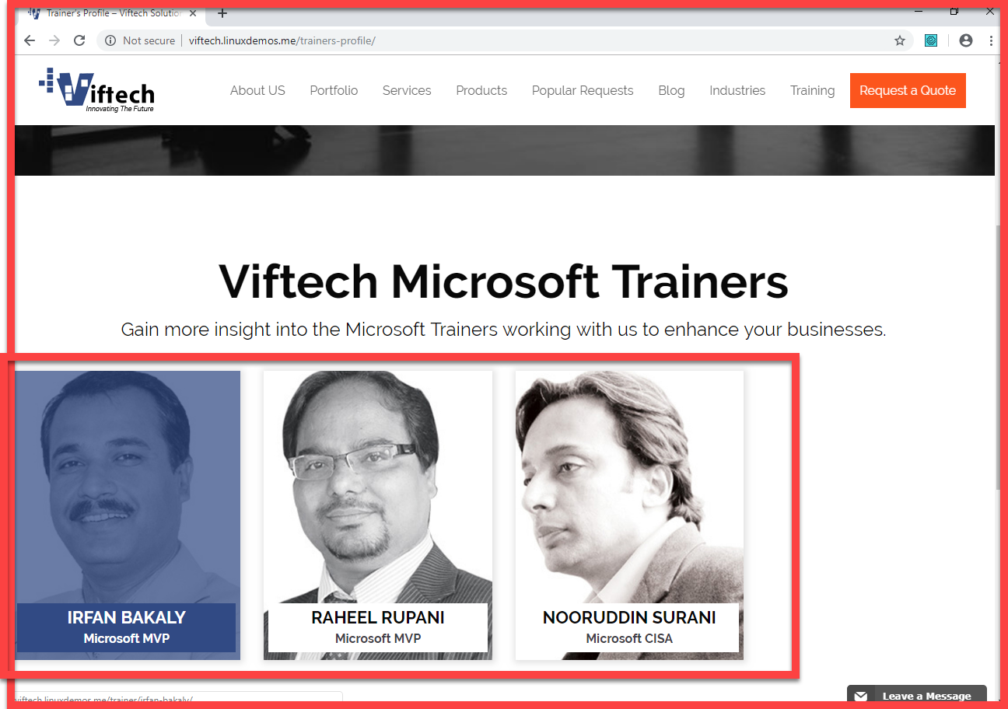

**ISSUE 11:**

**Title:**

On the Footer Issue

**Description:**

URL: <http://viftech.linuxdemos.me/web-design-and-cms/>

Resolution: **1920x1080**

**Steps to Reproduce:**

**Step1:** Go to Data-warehousing

**Step2:** Click on Costumer website development Learn more link.

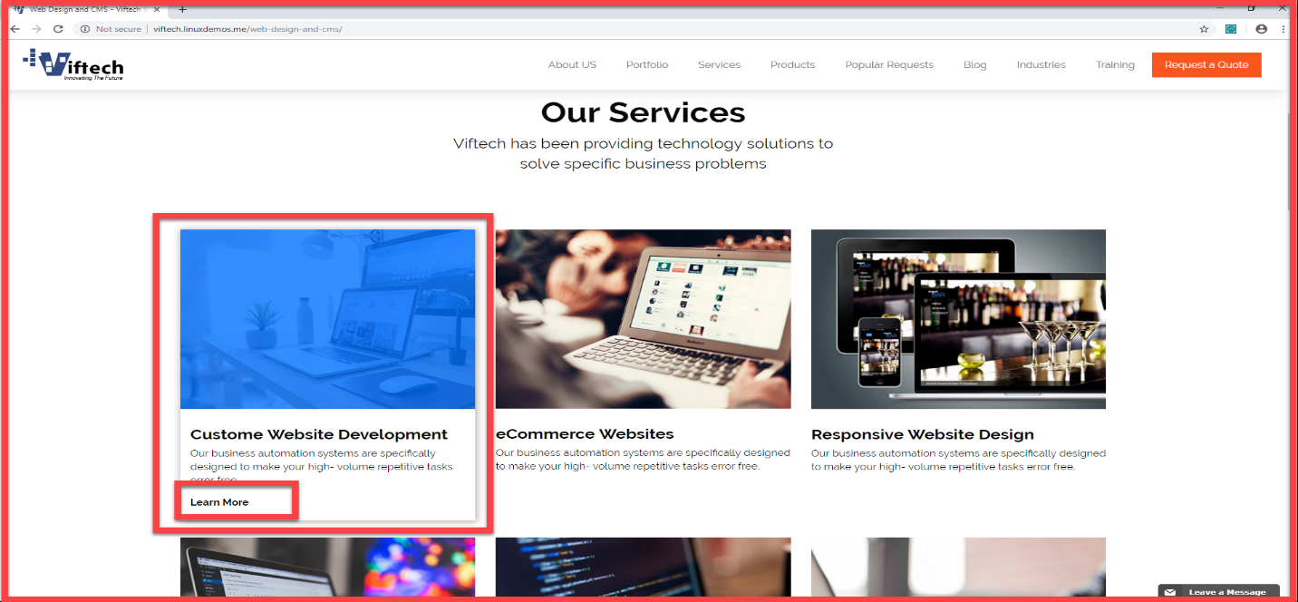**Step3:** Its should take to Costumer website development page but it take it back to web design and cms page.

**ISSUE 12:**

**Title:**

On the Footer Issue

**Description:**

URL: <http://viftech.linuxdemos.me/business-intelligence/>

Resolution: **1920x1080**

**Steps to Reproduce:**

**Step1:** Go to business-intelligence

**Step2:** Click on power BI Learn more link.

**Step3:** Its should take to power BI page but it take it back to business-intelligence page. 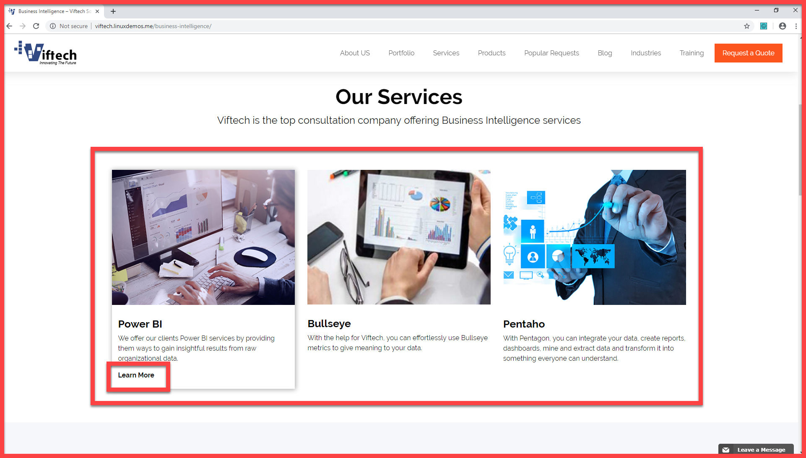

**ISSUE 13:**

**Title:**

On the Footer Issue

**Description:**

URL: <http://viftech.linuxdemos.me/training-programs/>

Resolution: **1920x1080**

**Steps to Reproduce:**

**Step1:** Go to training and click on training programs

**Step2:** Click on power BI Learn more link.

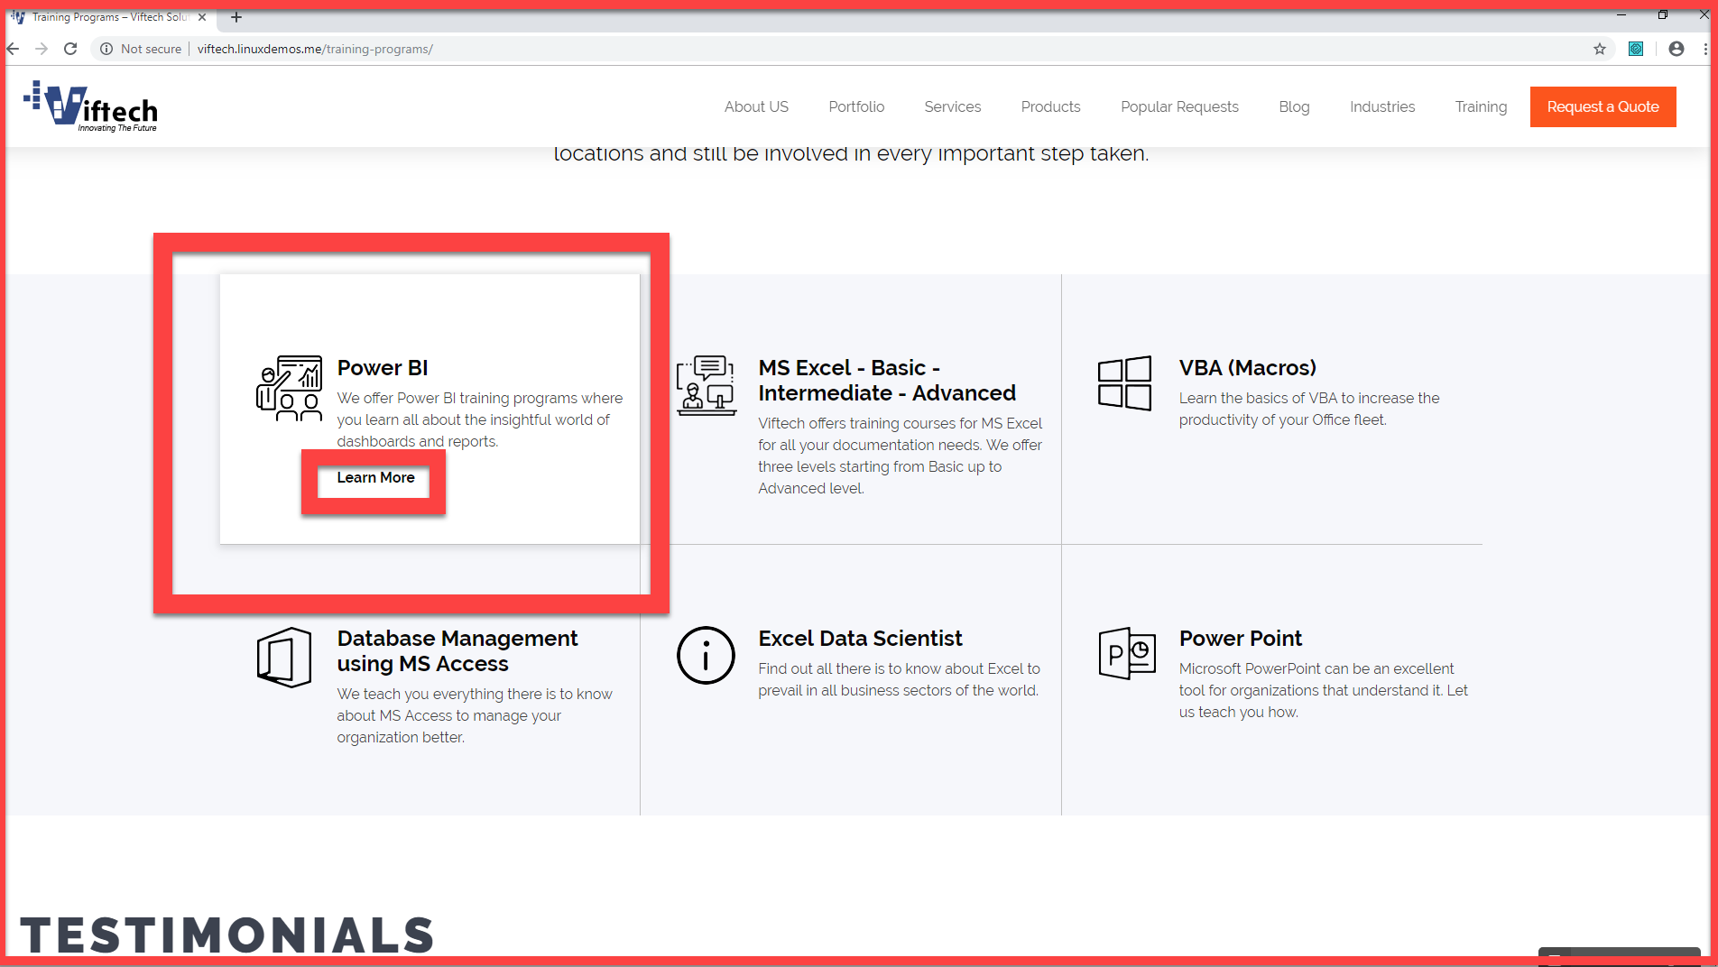**Step3:** Its should take to power BI page but it take it back to business-intelligence page.

**ISSUE 14:**

**Title:**

Testimonial Issue.

**Description:**

URL: <http://viftech.linuxdemos.me/training-programs/>

Resolution: **1920x1080**

**Steps to Reproduce:**

**Step1:** The testimonial slider timer should be increase.

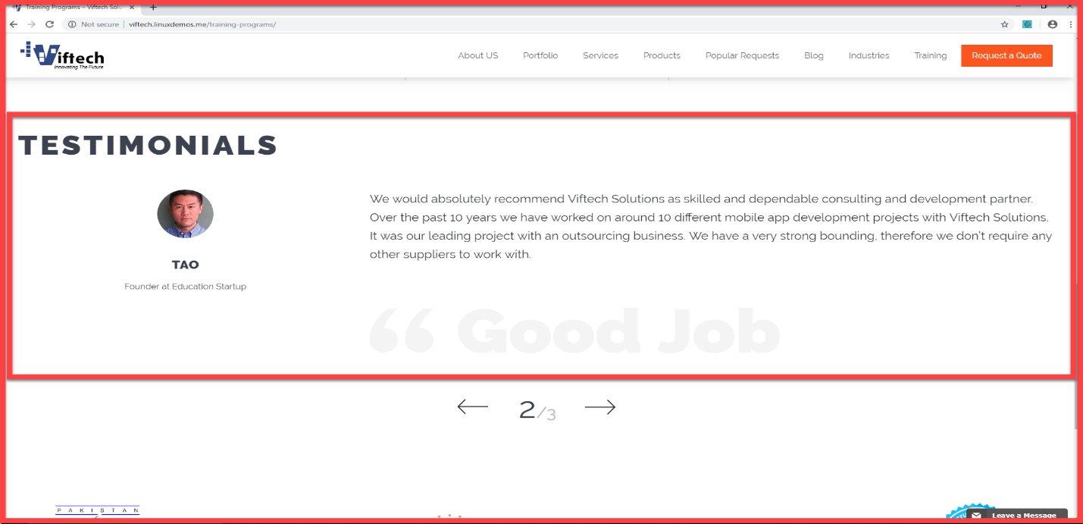

**ISSUE 15:**

**Title:**

Portfolio Mobile App Issue.

**Description:**

URL: <http://viftech.linuxdemos.me/portfolio/#mobile-app>

Resolution: **1920x1080**

**Steps to Reproduce:**

**Step1:** Go to portfolio and click on Mobile App.

**Step2:** When we click on American university of Virginia State learn more link.

**Step3:** Its should take to American university of Virginia State page but it take it back to portfolio Mobile app page.

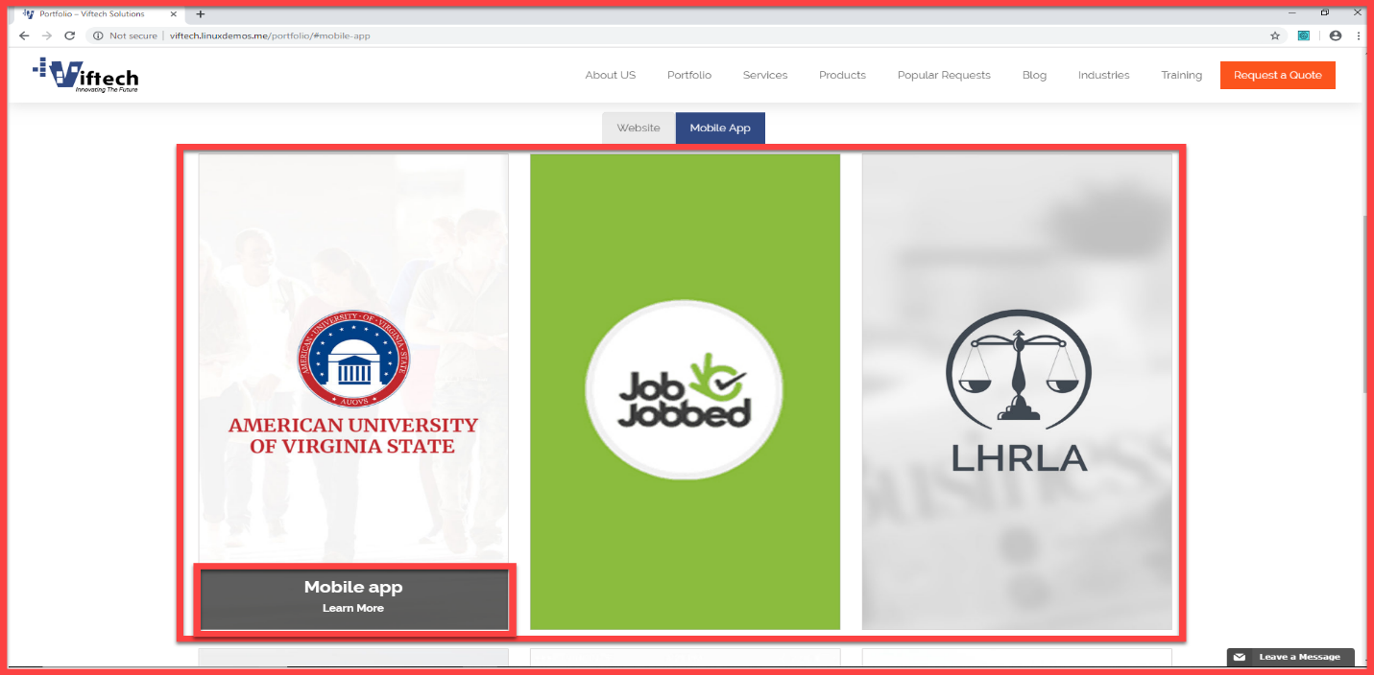**Step4:** There should be a proper redirection.

**ISSUE 16:**

**Title:**

Portfolio Mobile App Issue.

**Description:**

URL: <http://viftech.linuxdemos.me/training-calendar/>

Resolution: **1920x1080**

**Steps to Reproduce:**

**Step1:** Go to training Calendar.

**Step2:** In training calendar the registration button is not working.

**Step3:** The registration button should be functional.

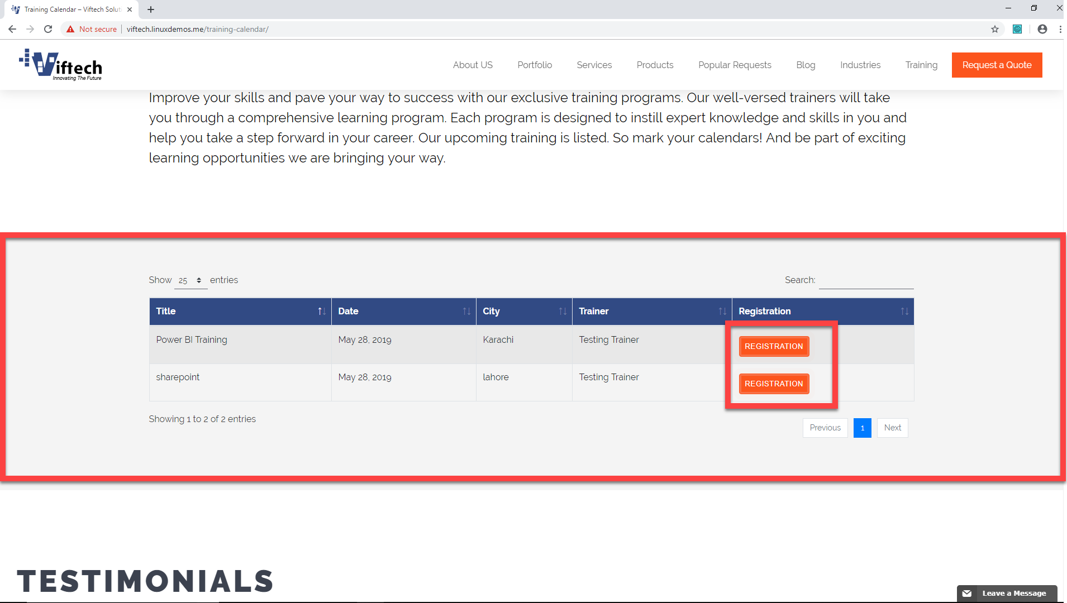

**ISSUE 17:**

**Title:**

# Portfolio Responsive Website Design Issue.

**Description:**

URL: <http://viftech.linuxdemos.me/responsive-website-design/>

Resolution: **1920x1080**

**Steps to Reproduce:**

**Step1:** View portfolio button is not aligned.

**Step2:**  This Button should be aligned.

